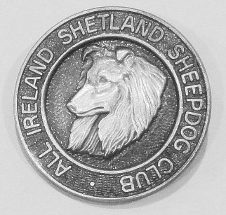
Affiliated to I.K.C.

President: Mr. J Kirk Secretary: Mrs. J. Walsh.
12 Saint Joseph Villas, Athboy,
Co. Meath.

Tel: (046) 9432027.

APPLICATION FOR MEMBERSHIP

NAME OF APPLICANT(S) ……………………………………………………………….

ADDRESS ……………………………………………………………………………….

……………………………………………………………………………….

SIGNATURE(S) …………………………………………………………………………..

SIGNATURES OF TWO PAID-UP MEMBERS WHO WISH TO PUT FORWARD THE ABOVE FOR MEMBERSHIP

1) ……………………………………………………… DATE ………………

2) ……………………………………………………… DATE ………………

STATE ANY SPECIAL INTEREST YOU HAVE IN SHETLAND SHEEPDOGS

………………………………………………………………………………………………………………..

………………………………………………………………………………………………………………..

FROM WHOM DID YOU ACQUIRE YOUR SHETLAND …………………………………………….

DO YOU OWN OR BREED ANY OTHER DOGS ………………………………………………………

Please send this form completed together with Current year’s Subscription of €5 per member – to the Hon Secretary, address above, and your application will be put before the next Committee Meeting.

For Office use). Date Rec’d ………………. Date Elected ………………………..

